The Big Idea! Survivit2 products provide a new and better ways to help people survive the world around them when disasters strike with dignity and respect; while balancing social, economic, environmental interest, offering excellent ROI to investors and high value to customers.
- The Core Solution - is to change the world’s current disaster response approach from multiple “piece-meal” slow delivery systems to a rapid reliable delivery system. A system that provides a “one-time individual package” (THE ULTIMATE SURVIVOR PACKAGE) that disaster victims can easily use and control utilizing our Single Point of Distribution ( SPOD) method. Suppliers will finally have a way to monitor who received packages and who still needs packages during a disaster event. These packages are complete and provide everything victims need for the short term, until longer solutions are available.

- We Don’t Want People to Stand in Long Lines - for hand-outs of different questionable products when every minute counts, that may not come. Nor do we want people trying to catch products thrown out of the back of trucks, planes or helicopters in a free for all chaotic way. All disaster victims need a variety of essential supplies to stay alive.

- Change By Design Concept – makes all the above possible. By providing unique breakthrough Disaster Products and Services, Innovations and Technology; and a Business Model like no other. However, we also need to be proactive, educate, train and help everyone receive products and services prior to a disaster, not just when disasters strike, which is no small challenge, but also is a great business opportunity!
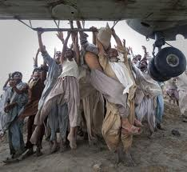
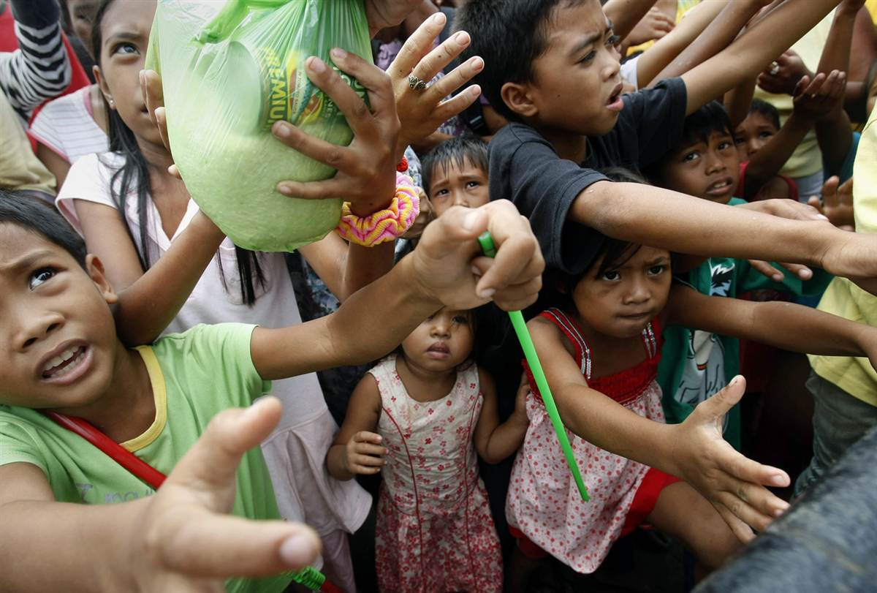
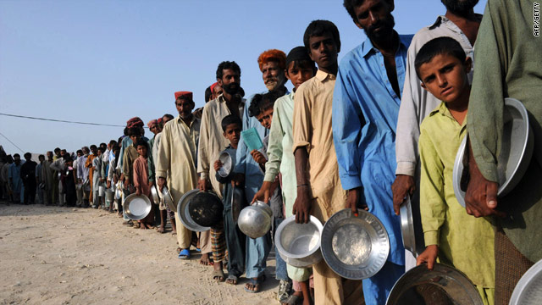
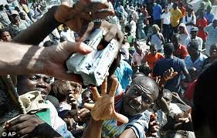
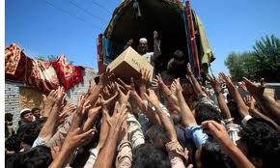
The two main disaster relief problems unsolved, till now, have been: Ineffective outdated products combined with a dysfunctional distribution system, which is shown below.

