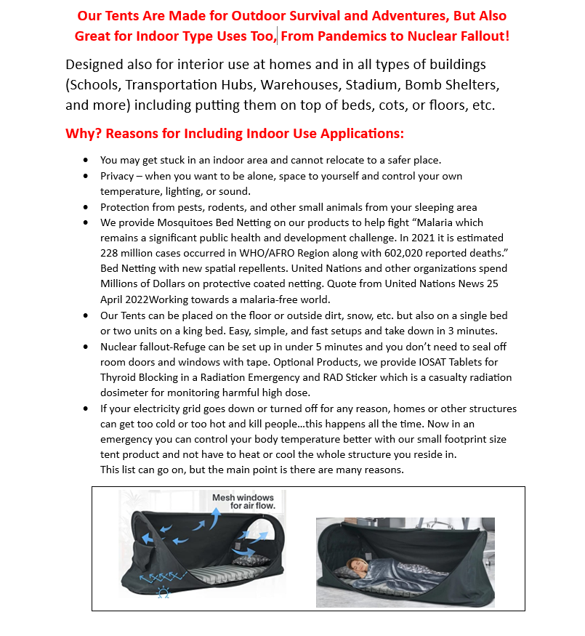

Refuge – Shelter and Protection, Cooling and Heating Enclosures
Our Custom Refuge Automatic Pop-up Tent for Adults and Kids
Kids Tent Size Can Be Carried on Most Commercial Airplanes, Set-up in Airports. Automatic Pop-up Tent Folds 3 Times, Carry Bag Size That’s Only 17” X 13” X 2” Inches.

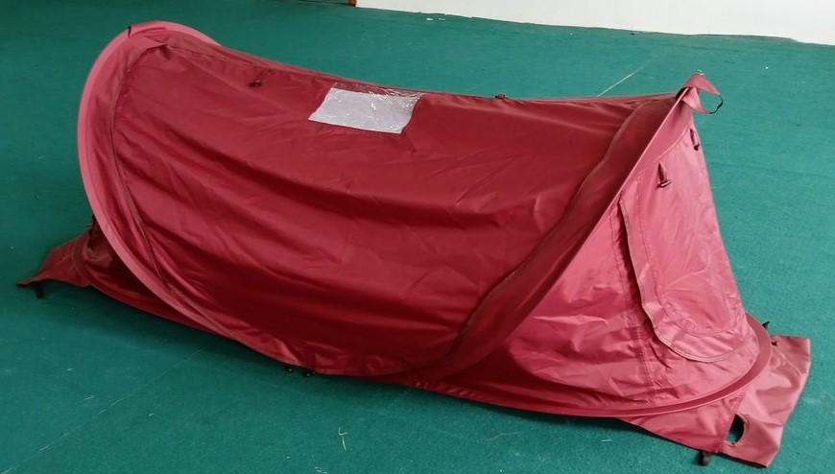
How to Open and Fold Adult Automatic Pop-up Tent to Fit Back in Carry BAG

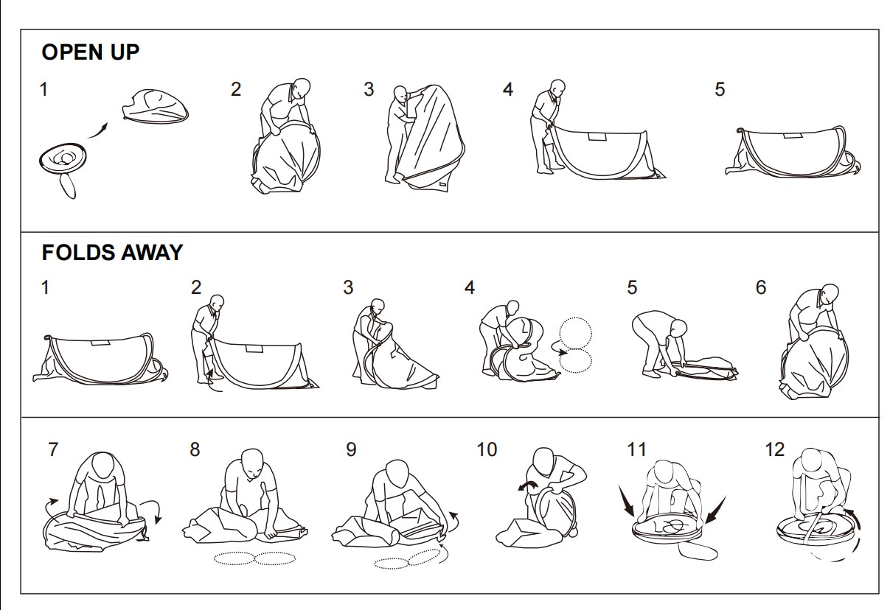
- First, these tents are four season products, including in snow conditions.
- They set up in seconds, not minutes without ropes.
- They convert into stretchers, hammocks, and emergency snow sleds.
- Make great cooling or heat sanctuaries, Inside or outside structures/environments.
- Small and light to transport, large and wide for large adults and heavy adults
- Long lasting, built-in footprints, reflective inside liner coating
- Ventilations are netting on 3 sides, mosquitoes, bug, and some animal proof.
- Triage signage visible from outside and clear window to see inside person if desired.
- Artica Air optional products available with custom connection means for Cooling Heat
- Hanging Hook for Lighting, Zipper Night Reflectors for easy location in the dark

