ALL NEW CONCEPT- 1st Responder Emergency Telescopic Gurney!
Floatable & Backpackable When Going Faster, Further, Doing More Work Required.

This gurney’s emergency survival design is Best…found nowhere else!
SAVE LIVES REDUCE SUFFERING LOWER COSTS PROTECT ENVIORMENTS

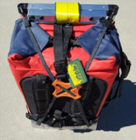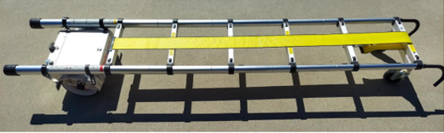
Go from 26” to 6’ 6” length in seconds

Gurney - a wheeled stretcher to transport people, items and pets. Bed on wheels for all people.
Our ultra-light and compact gurney is only 26” high X 18” wide X 7” deep and extends to 6 feet 6-inch-long X 18 inches wide X 7 inches deep with large 7 ½ “Half Flip Wheels (Patent). It has a lockable aluminum case, used as a tool device or storage in a variety of ways that is attachable or detachable, depending on the job/objective at hand. Furthermore, it can be used as a ladder. It comes in two configurations, small or large backpacks, large dry-bag backpack 18” x 24” x 10”.
And our Automatic Pop-up Tent, Bag-inflate Air Mattress, Fire Cloak Garment and Blue Stretcher can be used independently or be easily attached to our gurney. Also, this gurney can be air lifted by helicopter or other means and comes with sturdy handles for easy movement.
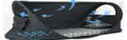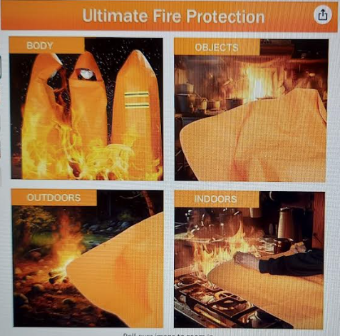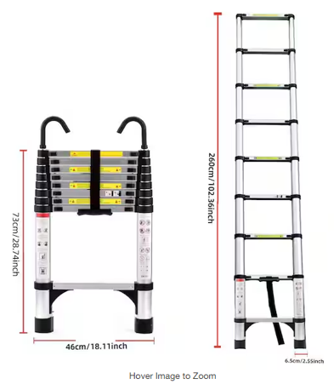
Basic Gurney Configuration Weight of Parts: 26 lbs. i.e., Gurney/Trolley Cart and Backpack.
Designed to be used from sea to mountain tops in all weather conditions. Provides off-the-ground refuge (sleeping and protection) 5” off surface. Unit can float in water with patient on it and other goods. Rated to handle a Patient up to 300 lbs. Furthermore, this product can be used as a sturdy telescopic hook ladder with or without the aluminum case or handle hooks.
Product items sets-up in seconds, not minutes with spring loaded Automatic Pop-up Tent, Fire Cloak Garment (to escape/resist fire flames and heat), Air Mattress -with Bag Inflatable Air Mattress, etc. Optional Skid capability available with additional part (for Snow or other surface).
Self-transportable in three basic ways, hand carry, backpack, and as a trolley cart. Store more gurneys in smaller space, behind seats of ambulances, air planes, trucks, boats, at air ports, etc.
