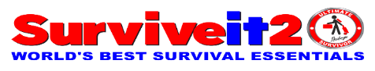
For 2026, Introducing The Ultimate Survivor Package™
The best, off-grid capable survival, and adventure product yet. Go behind the design and learn more about how we brought this incredible, revolutionary survival gear to life.

The Ultimate Survival Package™ is a modern answer to a timeless desire to survive whatever happens in life. With its state-of-the-art complete and effective survival system, unique refuge (shelter and protective capability) and self-transporting features of all items bundled together.
The Ultimate Survivor Package allows you to extend your horizons, go further afield, and stay there longer in comfort, hope, and dignity with the BEST LIFE ESSENTIAL package of items ever imagined and assembled. Yes, you now have a viable choice to protect yourself and others.
Surviveit2 LLC founded in 2007 with four basic goals: Save Lives, Reduce Suffering, Lower Costs, and Protect our Environments. Together we can advance these doable measurable goals in this never-ending journey by doing the best for most people worldwide today!

Listening, Learning, Responding
Never content to sit on its laurels and past achievements, Suriveit2 LLC constantly works to identify the emerging wants and needs of World Disaster Victims and Outdoor Adventure Communities—current users of Emergency Preparedness Items and all potential future buyers—to create products that meet those needs. That effort involves everything from the marketing department’s sophisticated research efforts to monitoring comments in online forums to conversations with dealers and one-on-one chats with community members at Trade Show events, Community Emergency Response Team meetings, Red Cross, and other organizations.
We have spent a lot of time (19 years now) at asking people what they wanted in our products, and the answer was the freedom to go more places with the comforts of home for a longer period of time,” People expressed a real desire to be prepared if they can’t shelter-in-place at home, with little or no notice, and have the peace of mind they can survive on their own beyond Refuge Areas, campsites and be able to explore remote places like National Forests and BLM land. And there’s interest in the Adventure Community to be more self-reliant and have better gear.
Everything our team has done has been cross-referenced research and our passion for better survival information to have simple effective products to survive safer, better, longer, that also provide comfort, hope, dignity in the process, than other currently worldwide market products.
Based on this insight, led by our engineering and design teams, we set about creating products capable of meeting the wants and needs of this growing segment of the Disaster and Adventure Recreational community. The goal was to create something familiar, but unique, new, and superior. A revolutionary product that reflects the go-further-stay-longer ethos in every aspect of its design and engineering. Remarkably, the company met all its stated objectives, no easy task!
For instance, to help users of this modern marvel product take it to wherever they want to go, the engineering team designed our Trolley Cart/Wagon with large Flip-Half Wheels, wheels that literally fold in half to be stored compact, added ground clearance, has no run-flat- tire concept built to handle the roughest terrain. These tires are the lightest weight, most economical and best solution for the tasks at hand. These Trolley/Cart tires, sturdy and lightweight, allow users to backpacked the Trolley Cart/Wagon and serves many other functions we will describe later.
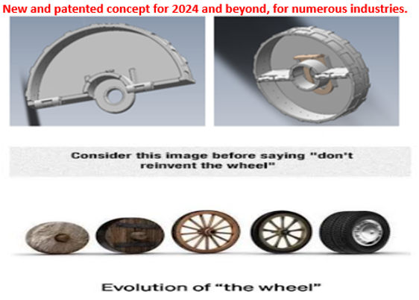

The project unfolded in multiple focused phases, marked by ongoing conversations, collaborative decision-making and milestone meetings among executive leadership and its engineering, design, sales, service, purchasing, marketing department, and with outside consultants and companies.
As in every Surviveit2 LLC design process, the first step was to set priorities after goals.
We sorted through all the input to decide what features were must-haves and which were nice-to-haves. “The top priority was clear: provide all the essentials of life and means to self-transport bundled items to give people more freedom to travel almost anywhere with the comforts of home. According to statistics compiled by NOAA and other organizations, we learned that Heat kills more people worldwide than flooding, tornadoes, hurricanes, or lighting. Stated another way, Heat kills more people than any other weather-related hazard. So, how do you protect people from Extrema Heat, wherever they may be, home, work, recreation, or just out. At the heart of the problem is to control people’s body temperature in all environments (ambient temperature-the overall temperature of outside air that surrounds us) they be in, at any given time.
The best way is to provide knowledge, then adequate mobile Refuge (shelter and protection) that are four season to beat the heat and the cold. We developed personalized tents that are light wight, small size (14” or 18” Diameters X 1/1/2” Wide) that spring open in a second, and accommodate everyone from infant to large adults, including the disabled. That includes being able to use it for carry-on luggage to commercial Air Line Carriers. We use space age materials and proven technology, including small portable A/C Swamp Cooler units, which make the difference! These tents transform into people’s stretchers, hammocks, emergency snow sleds, and triage post. Now, that’s real innovation! This is just one of our unique patented multi-functional products included in The Ultimate Survivor Package, which sets us apart from all other current companies and products. We have First-in-Market concept and ideal competitive advantage position.

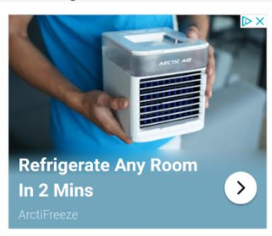
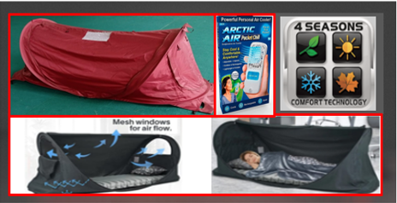

This type of decision and focus would drive many other design decisions and considerations, to focus first on customers’ needs and wants. Our Number One Priority is Customer Survival!
Delivering Life Essentials
Providing self-transportable Life Essentials was obviously central to the mission of creating the perfect Disaster Emergency and Off-The-Grid Adventure products for everyone. Because almost everyone travels distances at times. So, it’s no surprise that our Trolley Cart/Wagon system is at the heart of this rugged, versatile concept. Its two basic configurations cover everyone, from infants/kids/small adults to senior large adults, including the disabled person. No easy feat to do! But doable with faith we could achieve our goals for everyone’s sake! We make our products to be Professional Grade, tough and strong for repeated use and long lasting of great value with First Responder Personal in mind. Knowing lives are on the line when minutes count, and only the best products will provide the needed results.

Challenges Result in Benefits
You could say The Ultimate Survivor Package is built ground up, around our impressive Trolley Cart/Wagon. All decisions include consideration regarding weight and size of all items.
Our engineers added Solar Cooking features for maximum survival efficiency. Not to just cook food, but desalinate salt water, purify water, sterilize utensils, and for many other health and safety reasons. See our complete reasons why Solar Cooking, in our Humanity Perils and Your Survival information documentation series.
See our full list of features and benefits on our web site to better understand all that we offer.

From Concept Design to Production Process

Every product starts off as a dream, to create something, to solve a problem…
The Ultimate Survivor Package design began life as a group of Computer-Aided Design (CAD//CAM) drawings – essentially digital blueprints. The CAD system provides a way for engineers to quickly try out and “see” various design elements and layouts.
As the CAD process progressed, engineers began building and testing key elements of the all-important Trolley Cart/Wagon system. Once a CAD-generated design was agreed upon and approved, the engineers and designers began building a series of models. The first was a scaled-down mock-up to help bring the concept to life. Next came a limited full-size prototype used to assess the performance of the design’s systems, which was assembled and tested. Finally, the team built a full-sized prototype incorporated everything they learned in the design process and featured many revolutionary benefits of such a product.
Like all products, The Ultimate Survivor Package underwent rigorous testing. Components and functions, including the solar cooking systems, were tested repeatedly during the design process. The completed product was subjected to extensive live testing in Pacific Region.

Creating a Design that Supports Outdoor Adventure
We are striving to make improvements based on customer feedback.
The design team’s objective when creating new products is to create solutions that support the new products intended use.
We're involved with the engineering teams from the start of every new product design. We typically start the process with an initial idea, premise, theme or target and build upon that for the entire design. We want to facilitate outdoor adventure while providing all the comforts, amenities, and luxuries of glamping, which is luxury camping.
While some models feature first-of-their-kind patent ideas, the engineering and marketing teams decided to use 3D drawing for layouts and high gloss professional pictures in lecture.
The idea was to pack a ton of innovative technology into one of our most popular products to create an excellent off-grid experience.
The Privacy Room allows showers and toilet use in privacy.
“The overall look is intended to evoke a rugged professional product that will do the job and last for years, which it will. The Trolley Cart/Wagon is made from 1/8-inch Stainless Steel.
We wanted to recall the idea of nature to instill the idea that this unit can be used to get deep into nature for extended periods.”
Want to learn more about what makes The Ultimate Survivor Package the perfect off-grid travel partner? Download a brochure and learn more about the features of this transformational product or go to our web site at WWW.Surviveit2.com

YOUR SURVIV
is our number one priority

YOUR SURVIVAL

