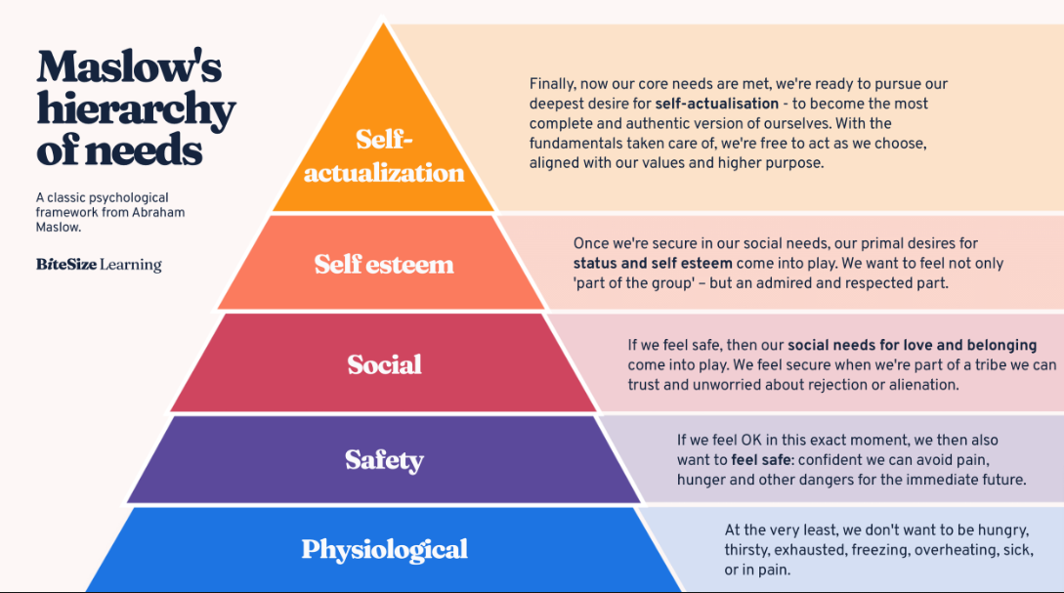
How we cover the spectrum of Maslow’s Hierarchy of Human Needs as outlined above.
Most brands sell products. The best ones sell possibilities. Customers aren’t buying what you make, they are buying who they become after using it! The Ultimate Survival Package offers you the possibilities of being a Disaster or Outdoor Activities Survivor anywhere, anytime, with our uniqueness and record of proven results.
This is the only (product) which provides Glamping, a portmanteau of ‘glamorous” and “camping” - an elevated form of traditional camping trip, of luxury camping gear, setting new higher standards of foot travel.
Physiological and Safety Level-What we are offering is your potential to become a survivor/hero of a disaster, be it Natural, Manmade or Outdoor Adventure, and in a non-chaos and luxurious way. Our offering include:
- Off-the-ground refuge (sleeping and protection) from weather elements and insects/small animals. S
- Hot Meals and Fresh Water on the go- of various kinds from thermo cooking in bags to parabolic solar cooking and desalination of salt water.
- Self-Transportation -of all items bundled together carried or hand carted.
Social Level-People become connected by sure survival needs and the people who want to help others; there are Government, NGO organizations, Churches, Charities, to Prepper families and individuals who are all involved at this time in some form and are truly HEROS, helping people in their time of need without expectation of rewards for doing so.
People can become admired and respected as part of a social group by taking the lead person position or being part of a first responder group efforts in survival situations.
Self-actualization-with fundamental survival needs met in a fast, easy, complete, and effective way, we then can pursue our higher purposes in life aspirations having more time, lifespan to do so, in Highest Function.

