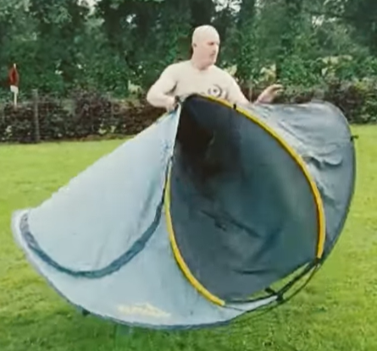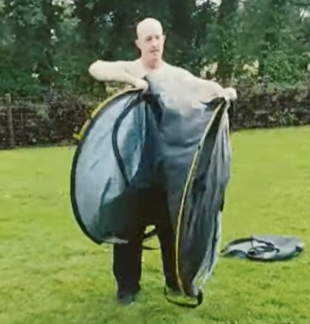
2. Right hand to left hand, fold it in half.
- Gather it up, like normal.

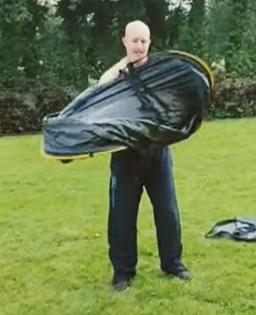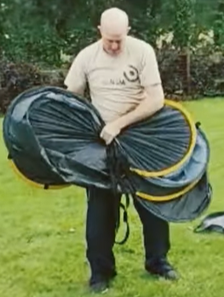
4. Fold it over, use tie down strap or just put it in the bag.
3. Make a figure of 8, turn your two hands together.

