Extreme Heat and Our Automatic Pop-up Tents
We have two different size Tents that both open in seconds and ready to use. Custom made and designed to easily place sick people inside of tents, have netting to keep out bugs and other unwanted things. Tents provide many uses, like an enclosed area, to help thermos regulate a person’s body temperature (cooling or heating). Tents can be used as hammocks hung from structures or helicopter air lifted with Straps to secure patients inside. Tents are durable for daily use, wind and snow resistant, and are Four Seasons Climate Rated. Both our Small and Large Tents are designed to be secured to our new Telescopic Gurney and rated for people up to 330 lbs. They provide better ways to save lives.

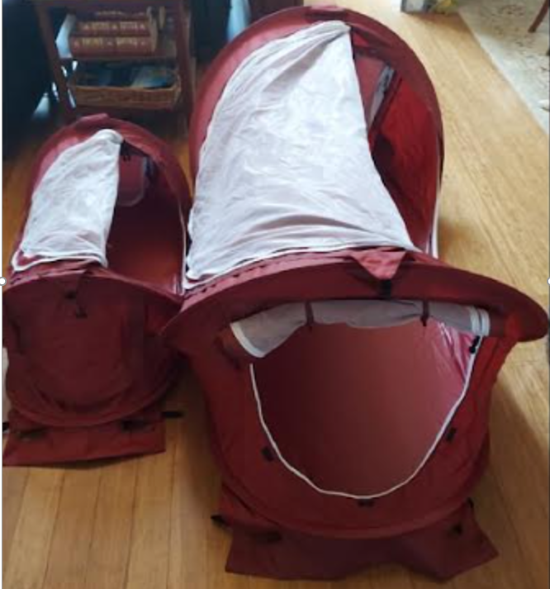
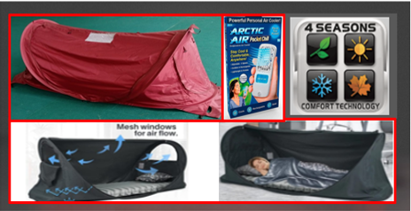
Small tent is 18”X18”X4’ long, 2/3rds the size of our large tent. Package size is 14” Round X 2” wide. Large tents are 28”X28”X6’ long and accommodates large people, 73 % of people in America are now obese. Package size is 18” Round X 2 ½” wide
Please Note: Extreme Heat often results in the highest annual number of deaths among all weather-related disasters. To reduce this heat condition/loss of life, we provide an Artic Air (swamp cooling device) inside our tents. Thus, we considerably lower the heat temperature inside our tent, especially when the tent is placed on top of our Telescopic Gurney that raises the tent 7” off-the-ground.

Turn the Page
According to the UN, 489,000 people died …. from Extreme Heat in 2023, 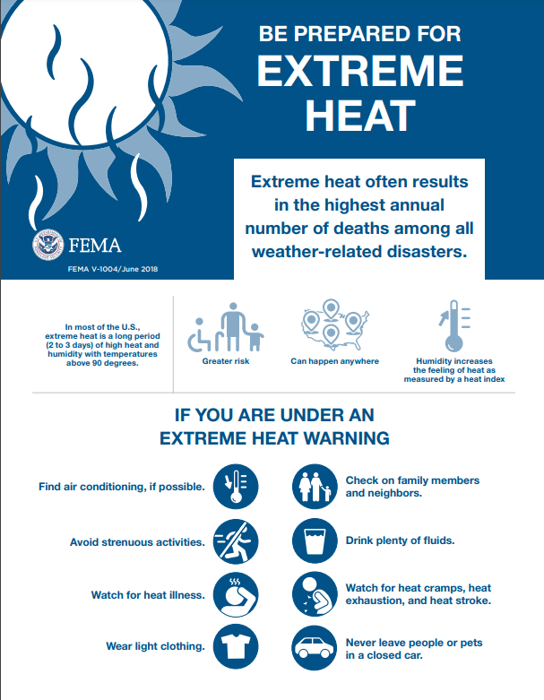
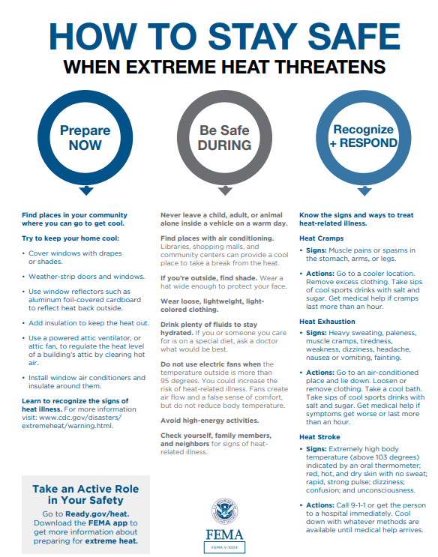
Around the world each year, Extreme Heat is expected to rise as the planet warms. But it doesn't get as much attention as other disasters. Part of this is because of the way heat kills.
- apnews.com › article › record-heat-deadly-climate2023 set record for U.S. heat deaths, killing in areas: AP ...
- May 31, 2024 · An Associated Press analysis of federal data shows that about 2,300 people in the United States died in the summer of 2023 with their death certificates mentioning the effects of Extreme Heat.
- Extreme heat is often called the silent killer. It’s the deadliest of natural disasters.

