Do You Know? To Live Longer Requires Knowledge & Action!

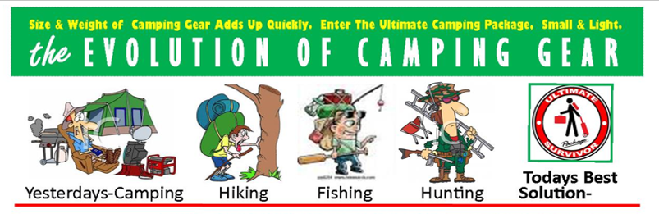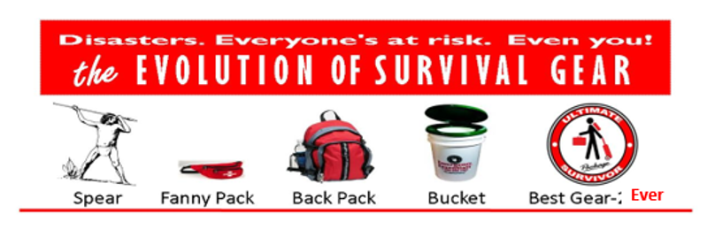

On Average Without Survival Essentials
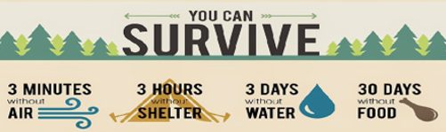

When disasters strike, people’s Breathable Air is the first immediate concern requirement to resolve or die! We provide N95 Face Masks or Supplemental Oxygen supply. Then Refuge (Shelter and Protection) is the next dilemma priority to resolve. Why? Because the leading cause of deaths and illnesses worldwide is not being able to thermoregulate a body’s temperature to stay alive. Core temperature elevation (hyperthermia) or depression (hypothermia) more than a brief time is incompatible with human life. Then the need for water and food too! We have viable solutions.
Read Below How We Are Change Everything, for Everyone, Worldwide!
With New Disruptive, Revolutionary, and Scientifically Proven Products.

Like our patented packaged essentials that are safe, simple, easy to use and effective; setting the First of Its Kind and Class Standard for Emergency Preparedness and other industries. Featuring rugged Off-The-Ground Refuge, providing enclosure protection from all seasonal weather elements, insects and small animals (nature creatures) that cause illness and/or deaths.
Furthermore, all our Survival Essentials can be self-transported together in 3 basic modes: by hand, backpacked, or Trolly Cart 2 or 4 wheel when basic transportation isn’t available. Products that are light weight, small, but big in versatility to transform into many needed aspects of survival. Utilized as a stretcher, wheeled gurney, hanging hammock, climbing ladder or bridge over a void area, etc. Also, they include 7 days of Hot Food, a Toilet, and Handy Tools.
To help guide you with your life’s survival decisions, we have a Free Survival Questioner Survey for you. Once your goals and needs are known, we offer our exceptional recommendations so you can achieve them. Also, is our Free map of the USA stating what types of disasters have previously occurred in various locations, to be aware of, plan for, and avoid when living in or traveling through.
Bottom line, we have the right Survival Life Essentials, in the right amount, in delivery time, at the best price to do the best for you and your family. Be a Survivor, prepare today and act!
Go from HELPLESS…to HELPFUL, to a SURVIVOR and TRIVER, be a HERO to All Who Need Help!

