Why Our Products Will Thrive?
Best All-In-One Package Survival and Adventure Solutions!

Our products make dollars and sense for Shareholders, Stakeholders, Governments, Customers and are the Best Products. From the different groups that make up this endeavor, each having their own motives and agendas, each group can align, support and rally around the Survival and Camping products and services developed and presented. These products are First-of-Their- Kind and Class in the Emergency Preparedness and Camping Industries and are distinguished by name, design, and multi-functional usefulness as “Packages”, a new category of products and services. We address specific industry concerns that have gone unresolved, until now, with new viable and realistic solutions, providing greater value and worth!
Products
Last For
Years
New
Features
&
Benefits
A Real
Needed
Product
Quantum
Leap in
Technology
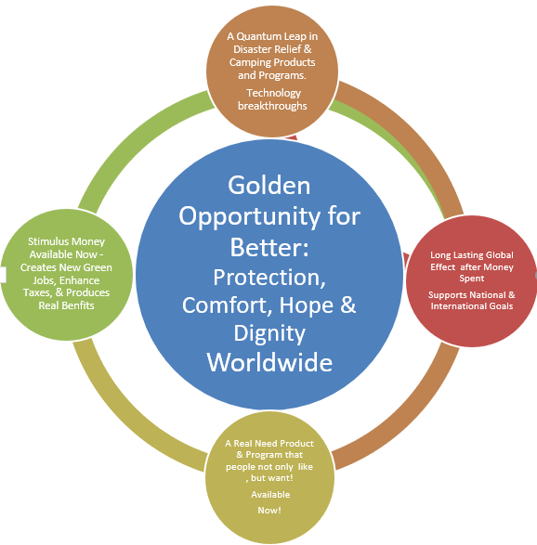
The Various Group Parts
Disasters – Happen Anyplace, Anytime and to Anyone!
- End Users – all people need essential elements, (water, food, shelter, and sanitation) to sustain life, even for a short time, it may be minutes, hours or days depending on the situation or circumstance one finds themselves in before more supplies or help arrives.
- Customers - People have a deep-rooted yearning to live. They want better choices; enough select choices make for social change, alters the status quo, and improves disaster relief responses. Customers are not necessarily End-Users, they may be FEMA, UN, etc.
- Inclusiveness/Inventors – we want to be a part of the solutions, but also recognize many other individual and companies for their contributions and accomplishments.
- Products – are not only essential for life, but contribute to daily life, i.e., solar cooker, see feature and benefits of all product offerings and why products can pay for themselves.
- Governments/Charity – need better products and services, greater value at low costs.
- Stakeholders/Vendors – need excellent return on investment for business risks involved.

