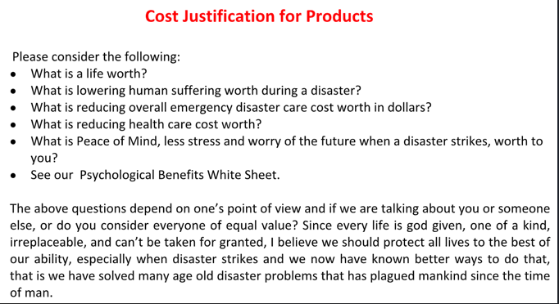
The Cost of Doing Nothing?

