My Journey
I am Alex J. Malavazos, the Founder/CEO of Surviveit2 LLC. Today I want to tell you a little bit about my journey to do this type of work passionately and for the last 20 years!
How did I get here, why do I work so hard and enthusiastically about what I do? It is not about me, it has never been and I finally found my Purpose in Life helping others in this way.

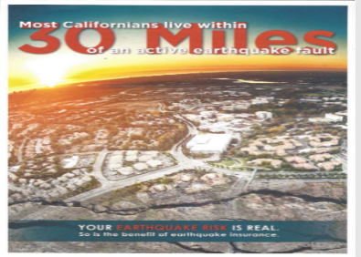 | I grew up in Hayward California and as a kid learned that most Californians live within thirty miles of an active earthquake fault. I was living on top of the Hayward fault and when the earth shook the joke was, we were going to own ocean beach front property someday! You could see the signs of the splitting earth; the Hayward fault ran right through the center of the Berkeley Football Stadium where the sidewalk shifted apart. Ever hear of the famous 1906 San Francisco Earthquake or the San Andres fault? The Bay Area, CA. is pictured at left.

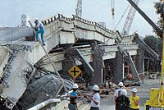 | The passion and desire to give back to others in their time of need grew out of my first-hand experience with the 1989 Loma Prieta Earthquake Disaster. At that time, I was in San Leandro, CA when the ground and buildings had a rolling up and down motion that caused our parking lot of cars to almost slap each other and it was hard to stand up-right as everyone ran out of the various shaking buildings! What we later learned, it was a 6.9 Earthquake killing sixty-three people and injuring 3,757 more! The Cypress Freeway was in Oakland CA. now demolished, pictured at left.

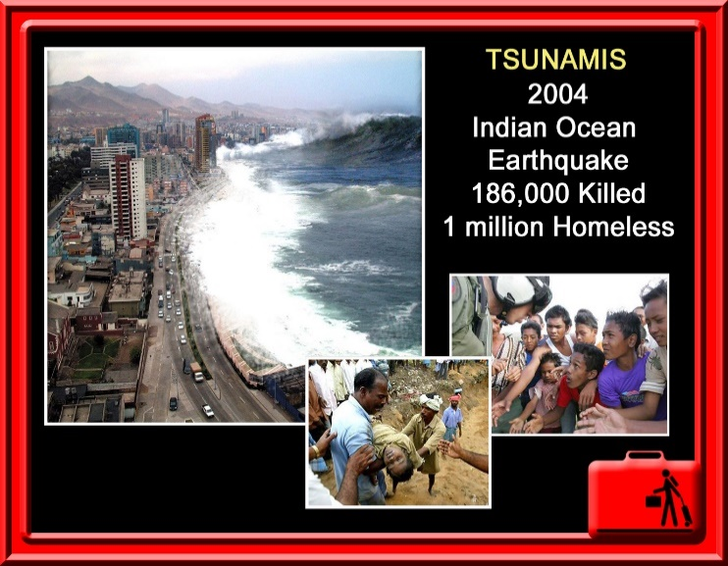 | Since then, I was even more inspired to learn more about disasters taking place worldwide and how other people were responding and coping with them. The 2004 Indian Ocean Tsunamis seen left killed 186,000 people and 1 million people became homeless. Nobody was prepared for this and on such a massive scale. Wow! It is a fact now, if you do not prepare for disasters, you are at the mercy of mother nature and man-made disasters and other citizens to come to your aide and rescue! If prepared you can protect yourself and might help others too!

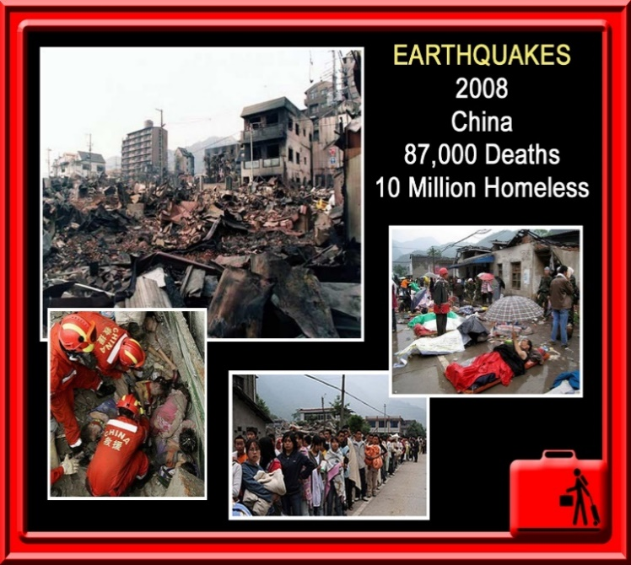 | Then in 2008 the China Earthquake struck causing 87,000 deaths and ten million people became homeless. Unbelievable! By now most people can recite disasters seen on TV in places like Haiti, Porta Rico, Flordia, Hawaii, Irland, Packastand and countless other places around the world.  Disasters are only getting worse for a variety of reasons, in size, scope and causing unprecedented horrendous human and environmental tragedies. No one can escape disasters entirely they affect everyone one way or another, from resources used to environment. Expect the Unexpected!

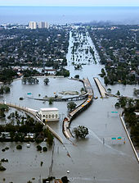 | But it was not until August 28,2005, that is when Hurricane Katrina hit the USA causing 1800 deaths and ½ Million people became homeless; I saw on TV a mother holding her child in her arms on a bridge surrounded by water. It was raining, and they had no protection to the elements and no way to get off the bridge on their own, dependent on others in a life-or-death situation. Eventually 80% of the city and large tracts of neighboring parishes became flooded, and the flood water lingered for weeks. Hurricane Katrina, pictured on the left partially reflects the total chaos!

Somehow this one image above of that lady and kid on the bridge (last picture above) became personal to me! Maybe because I was older now and saw way too many disasters and chaos!

My journey began there and continues today with the same passion and hope: to make a real difference for future disaster victims through education, innovative products and services, and collaboration with like-minded people. Disasters can happen anywhere, at any time, to anyone—without exception and do!
Since our humble start 20 years ago, we educated ourselves and embraced many new ideas and tools like: Behavioral Science Methods, Blue Ocean Strategies, Design by Change Ideas, How to Change the World Concepts, etc. which enables us today to provide the Best, Most Complete and Effective Multifunctional Disaster Relief and Adventure Products and Services ever imagined, that being our revolutionary new concept product The Ultimate Survivor Basecamp Package.
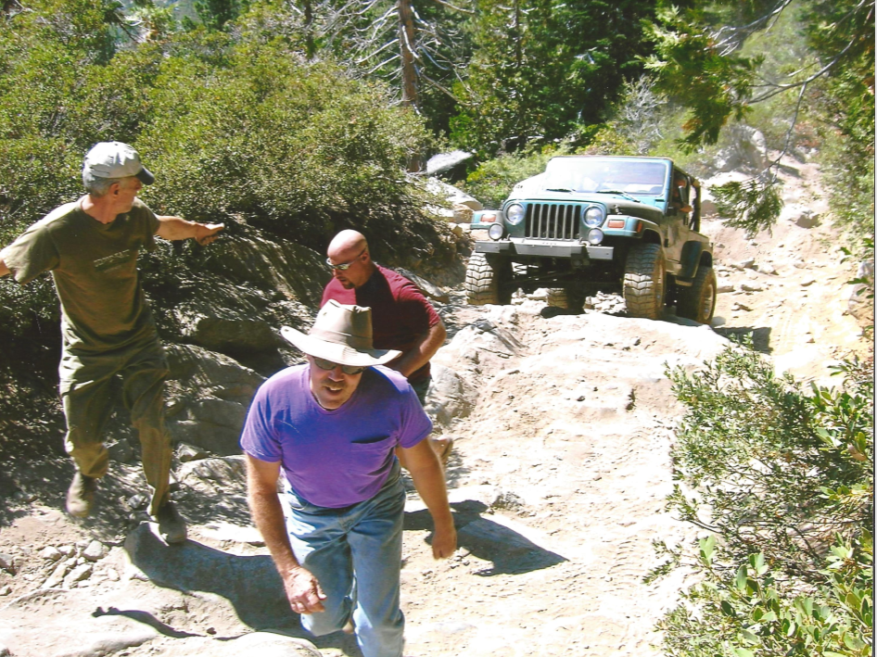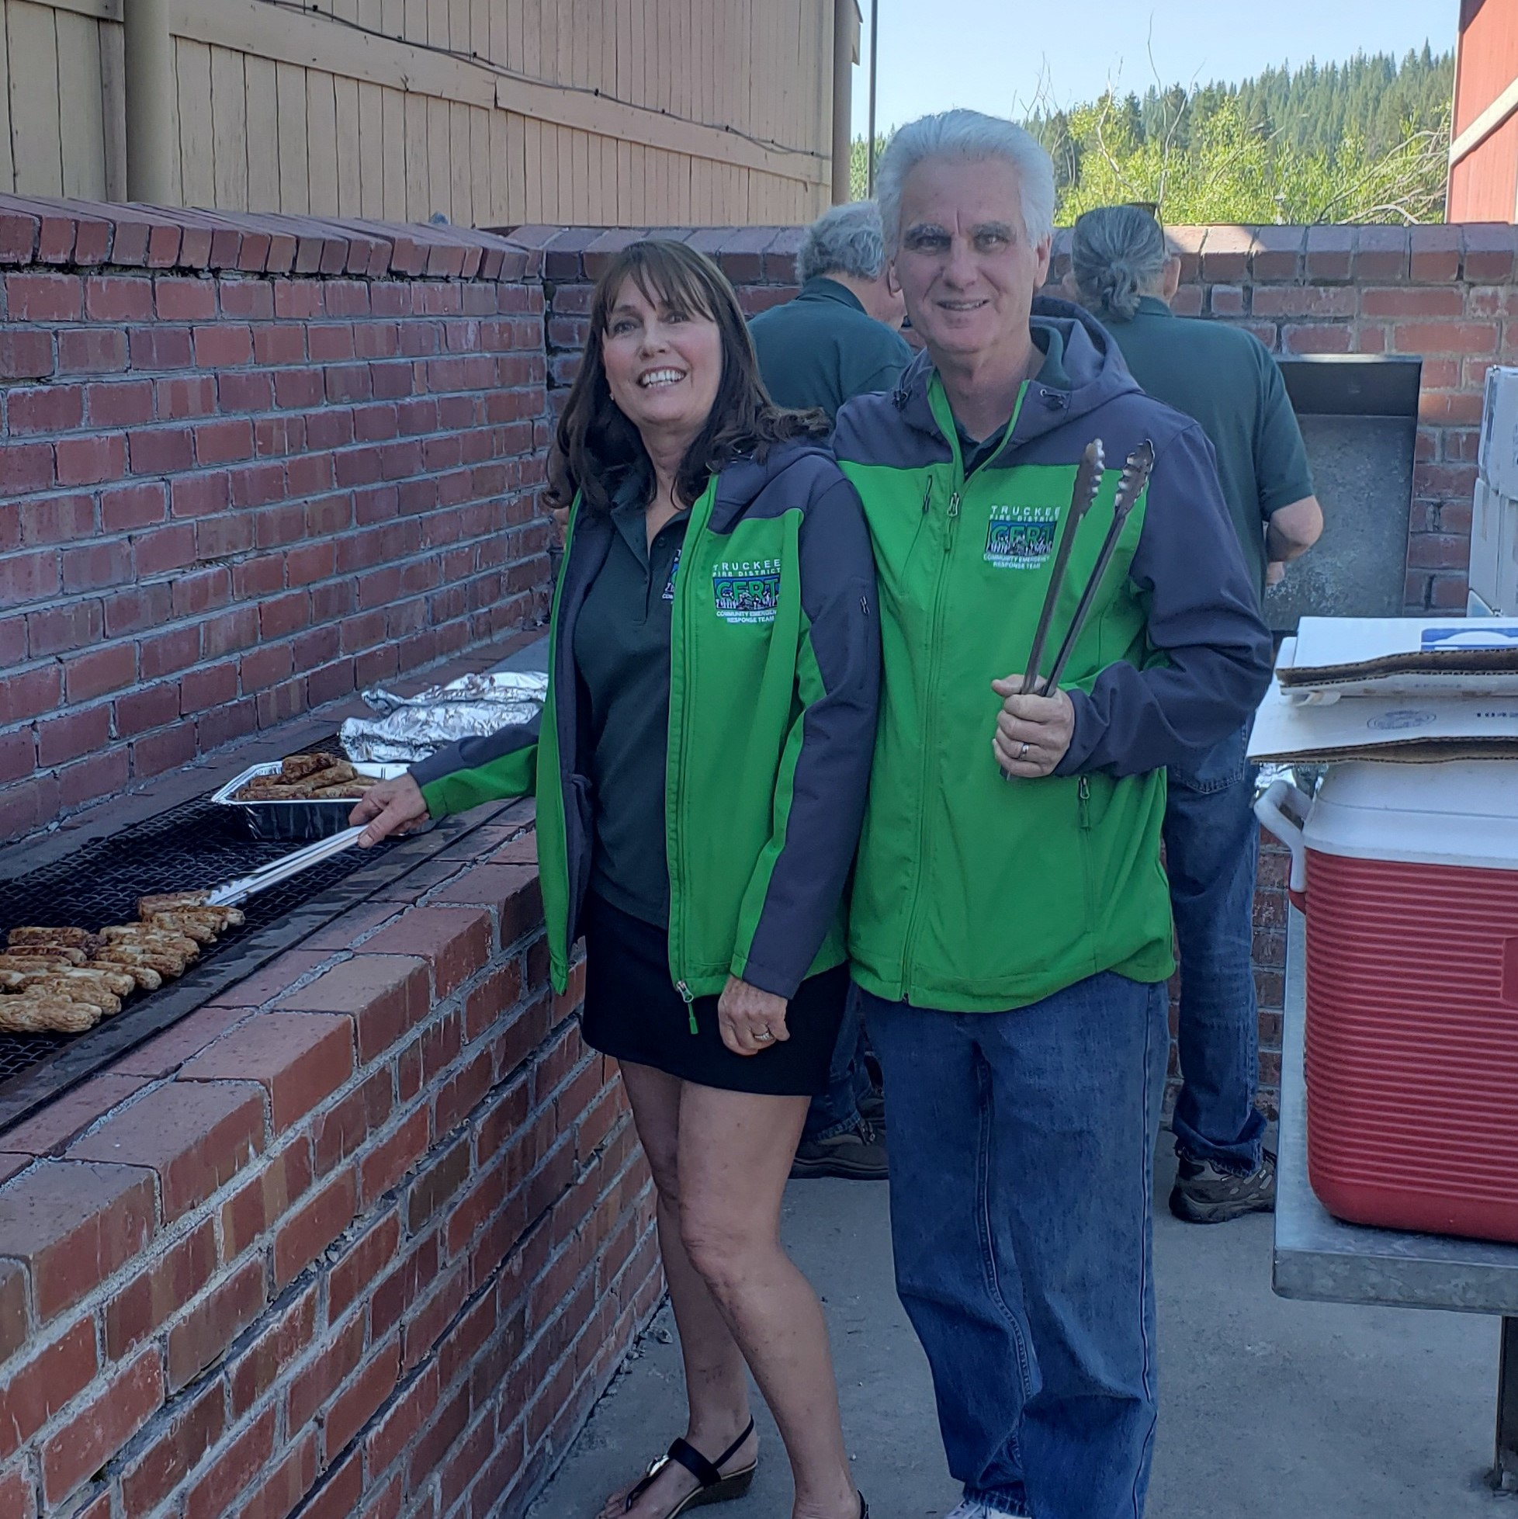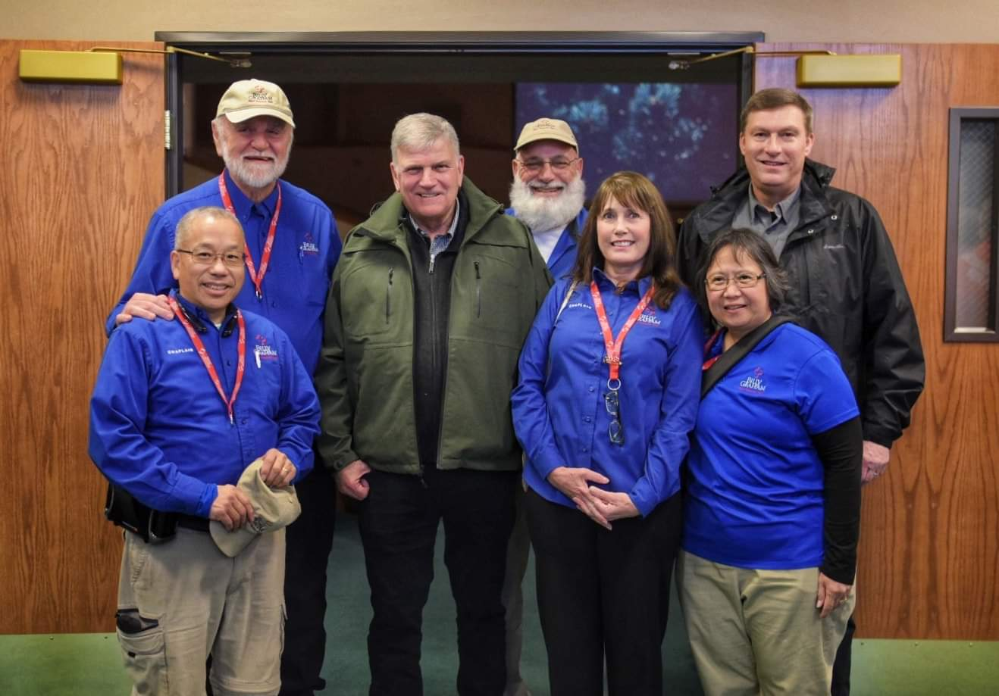
On the Rubicon Trail, CA. 4th of July 2019 Truckee, CA 2018 Paradise, CA - Worst Fire in CA.
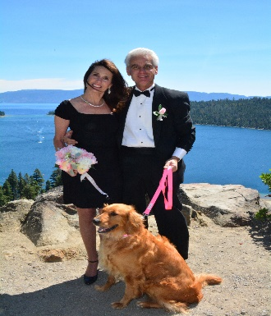 | Personally, I have been an outdoor enthusiast since childhood camping, fishing, and hunting with family. I got my first jeep in high school and own one until 2021. My deceased wife and were CERT (Community Emergency Response Team) members, and she was a Chaplin for Billy Graham Rapid Response Team, and California Highway Patrol. She also volunteers for our local hospital. We believe in giving back and helping everyone to the best of our abilities. We lived in the Lake Tahoe, CA area with our three Golden Retriever dogs, who love our beautiful lakes.

In Conclusion -

Most people see disaster products as life insurance—valuable only when the unexpected happens. We take a different approach by creating products that offer quality life assurance: practical tools that help sustain life and meet everyday needs. They can be used in many situations, including war relief, camping and adventure, homelessness support, migration assistance, and aid for adoptive children. Because they serve multiple purposes, they can help pay for themselves over time. Our core product, The Ultimate Survivor Basecamp Package, is a patented breakthrough built around the essential items people need to survive. It represents a major advancement in design and function that is Changing Everything for Everyone. See the Rule of 3’s for why these Life Essentials matter.
The good news is you do not have to learn all survival skills now. From gathering material and building shelters from scratch anymore, or how to purify water, build and maintain fires, etc. in the short term and you can concentrate on what other things you need to know and do, which is many! This translates into better survival outcomes while minimizing effort at lower cost and protecting environments!
So many people with so many divergent backgrounds and ideas have contributed to this project. We are enormously proud of our progress, the help & support we have gotten through the years from so many individuals, for-profit and non-profits companies, USA Governmental Departments, Schools and Charities, and we thank them all. Too many to list, but there is so much more we all need to do for a much safer world we all live in. And live longer with new viable information and Life Essentials we all need and can have now!
We still need your help and support now to turn this dream into a reality for everyone’s sake. Got yours? The Ultimate Survivor Basecamp Package. Do not fret or delay, get yours today and help others get theirs. Live Safer, Better, and Longer with Life Essentials for longevity.
This may sound like hype but is not an exaggeration. Survivwit2 products from New Technology Has Never Stops Evolving, nor will it, we only get better with everyone’s help for everyone!
Thanks again for everyone’s time, support, help, and dedication to this worthy project and Shine Your Light and help others Shine Their Light Too!
Alex J. Malavazos
Alex J. Malavazos
Founder/CEO Surviveit2 LLC (Survive it too)
Email: malavazos.alexj@gmail.con
Phone: 775-815-6015

