NOW, YOU CAN GET ALL YOUR HOUSEHOLD FULFILMENT ITEMS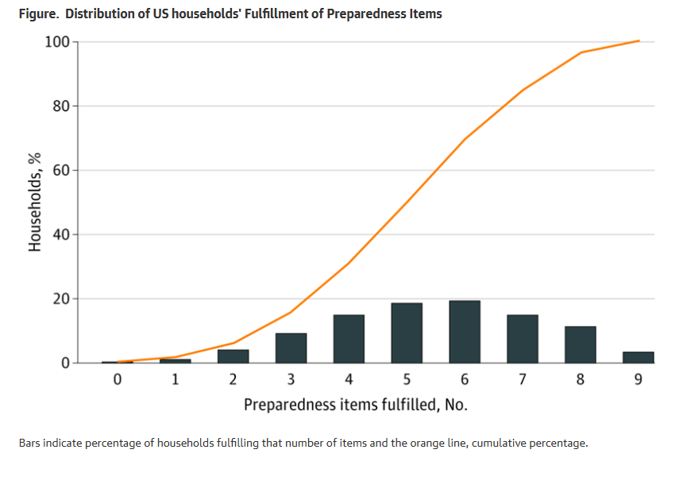
Check your risk.
Get personal insight into your current and future disaster risk.
Know your risk.
Take our personalized disaster survey and get insightful information on how disasters that might affect you and your family.
Reduce your risk.
Act with meaningful solutions to mitigate disaster risks and get knowledge and Life Essential Supplies you’ll will need, not just want!
FREE- NO COST TO YOU
SCAN QR CODE AND CLICK ON PERSONAL SURVIVAL SURVEY AND GET YOUR ASSESSMENT TODAY!
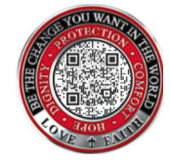

JAMA Netw Open
Published Online: April 27, 2020

