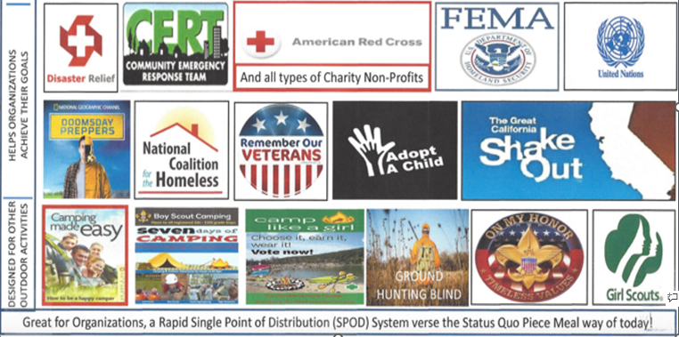
Above is just a small sample of organizations that can benefit from association with our company, we offer free help to everyone and anyone, just ask us!

