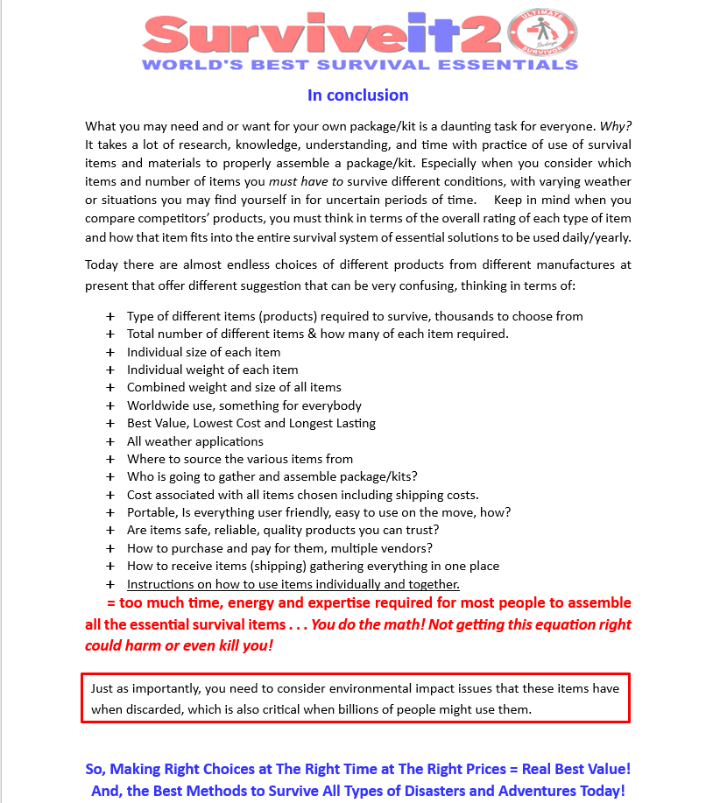
Instead, Get The Ultimate Survival Package!
Eliminate Confusion Guide

