Dream Big Work Hard Give Back
Each year, millions of people die within minutes, days, or weeks from preventable causes, including natural and man-made disasters. Everyone should understand life’s risks and secure essential resources to live better, longer, and healthier lives.
Life essentials include clean air, refuge—shelter and protection—water, and food.
Natural disasters include extreme heat, flooding, earthquakes, hurricanes, and similar events. Man-made disasters include wars, environmental damage, shortages of preventable life-essential resources, and diseases or health conditions with known cures.
SOLUTION
At last, having the Right Product, at the Right Time, for Right Price.
Doing something bigger than self that will spread to the ends of the earth. Thus, finding answers after 19 years of research and development to pre-set goals.
PROBLEM
The lack of existing knowledge, education, and innovation to Life’s Essential problems. The need for new products and services for a holistic (complete and effective) answer to save people in their time of need and protect environments.
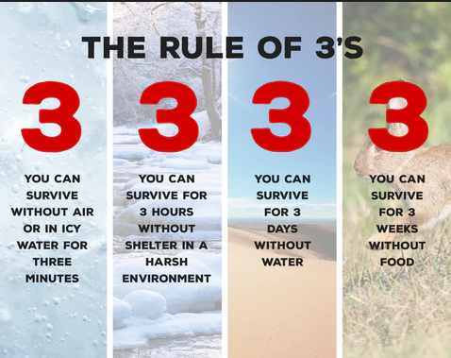

SEVEIRTY
CONSTANT CHAOS-
INCALCUABLE HUMAN SUFFERING, DEATH OF MILLIONS OF PEOPLE
MARKET SIZE
GLOBAL / WORLDWIDE-
INCLUDES EVERYONE,
EVEN YOU…
PROBLEM
LACK OF EDUCATION,
PLUS INADAUQAUTE
LIFE ESSENTIALS AND DISTRIBUTION
SERVICES

