Cost Justification in Dollars – Like Insurance but Better, Life Assurance!

What is your life worth?
What is not becoming sick worth?
What would you pay to reduce pain and suffering both mentally and physically?
What is the cost to others if you die?
We Encourage You to Buy Life Assurance Survival Products for the Living…
Not Just Other Type of Insurance or Life Insurance for the Expected Dead.

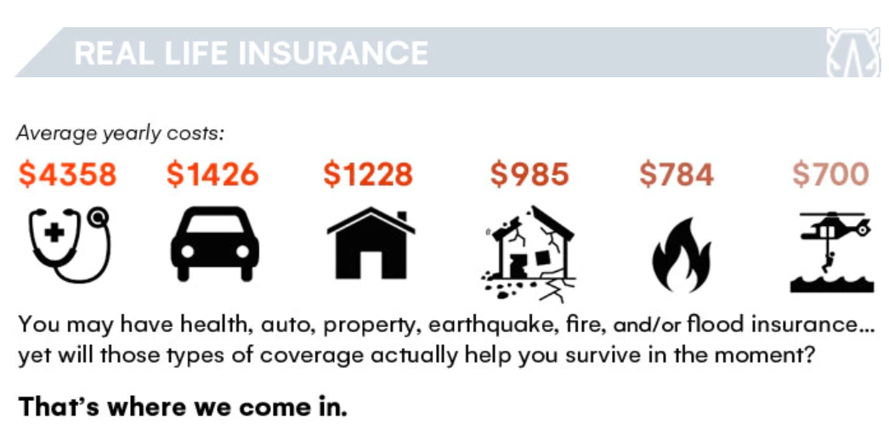
- Help you set priorities and understanding what really matters in the long run!
- Your Constant Survival is the most important thing for your Life’s Longevity.
- Your Longevity only happens when you Survive Disaster or Tragedy Events.
- Otherwise, your Life Dies on Earth. All other priorities become secondary.
- We have Protection, Comfort, Hope, and Dignity you cannot get anywhere else!

Please Note: Just one trip to the Hospital, Doctor Office, Ambulance Ride, Field Emergency Care can cost you more than our one-time product price which can last for years on end. Even the cost of certain yearly health coverage, auto damage, home damage deductibles could cost you more than our low price of product you only purchase once to start benefiting from!

Also, The Ultimate Survivor Basecamp Package Products pays for themselves in many other ways in no time. Like with our Solar Cooking Unit, which is the simplest, safest, most convenient way to cook foods without consuming never ending costly fuels or heating up the kitchen.

